LeetCode List Practice Questions:
21. Merge Two Sorted Lists
You are given the heads of two sorted linked lists list1 and list2.
Merge the two lists into one sorted list. The list should be made by splicing together the nodes of the first two lists.
Return the head of the merged linked list.
Example 1:
Input: list1 = [1,2,4], list2 = [1,3,4]
Output: [1,1,2,3,4,4]
Example 2:
Input: list1 = [], list2 = []
Output: []
Example 3:
Input: list1 = [], list2 = [0]
Output: [0]
Constraints:
- The number of nodes in both lists is in the range [0, 50].
- -100 <= Node.val <= 100
- Both list1 and list2 are sorted in non-decreasing order.
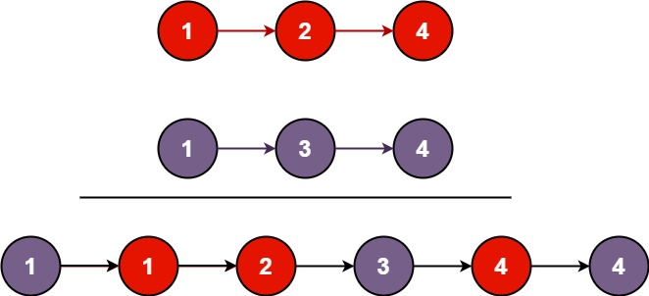

Solution #21 — Merge Two Sorted Lists. Using LinkedList and sorting
import java.util.*;
public class MergeTwoSortedLists {
public static void main(String[] args) {
LinkedList<Integer> list1 = new LinkedList<>(Arrays.asList(1, 2, 4));
LinkedList<Integer> list2 = new LinkedList<>(Arrays.asList(1, 3, 4));
LinkedList<Integer> merged = new LinkedList<>();
merged.addAll(list1);
merged.addAll(list2);
Collections.sort(merged);
System.out.println(merged); // [1, 1, 2, 3, 4, 4]
}
}

Problem #83 — Remove Duplicates from Sorted List
Given the head of a sorted linked list, delete all duplicates such that each element appears only once. Return the linked list sorted as well.
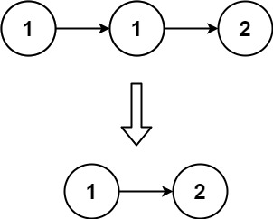
Input: head = [1,1,2]
Output: [1,2]

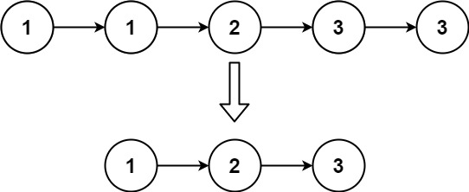
Input: head = [1,1,2,3,3]
Output: [1,2,3]

Constraints:
- The number of nodes in the list is in the range [0, 300].
- -100 <= Node.val <= 100
- The list is guaranteed to be sorted in ascending order.
import java.util.*;
public class RemoveDuplicates {
public static void main(String[] args) {
LinkedList<Integer> list = new LinkedList<>(Arrays.asList(1,1,2,3,3));
LinkedHashSet<Integer> set = new LinkedHashSet<>(list);
LinkedList<Integer> result = new LinkedList<>(set);
System.out.println(result); // [1, 2, 3]
}
}
Problem #19 — Remove Nth Node From End
Given the head of a linked list, remove the n^{th} node from the end of the list and return its head.
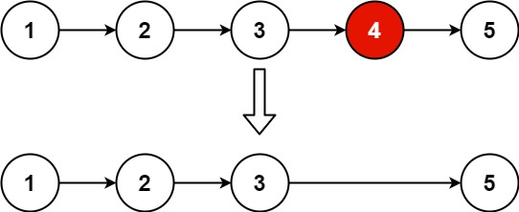
Input: head = [1,2,3,4,5], n = 2
Output: [1,2,3,5]
Example 2:
Input: head = [1], n = 1
Output: []
Example 3:
Input: head = [1,2], n = 1
Output: [1]
Constraints:
- The number of nodes in the list is sz.
- 1 <= sz <= 30
- 0 <= Node.val <= 100
- 1 <= n <= sz
Solution:
import java.util.*;
public class RemoveNthNode {
public static void main(String[] args) {
LinkedList<Integer> list = new LinkedList<>(Arrays.asList(1,2,3,4,5));
int n = 2;
list.remove(list.size() - n);
System.out.println(list); // [1, 2, 3, 5]
}
}
Problem #24 — Swap Nodes in Pairs
✅ Using Collections.swap()
import java.util.*;

public class SwapPairs {
public static void main(String[] args) {
LinkedList<Integer> list = new LinkedList<>(Arrays.asList(1,2,3,4));

for (int i = 0; i < list.size() - 1; i += 2) {
Collections.swap(list, i, i+1);
}

System.out.println(list); // [2, 1, 4, 3]
}
}

Problem #86 — Partition List
Given the head of a linked list and a value x, partition it such that all nodes less than x come before nodes greater than or equal to x.
You should preserve the original relative order of the nodes in each of the two partitions.
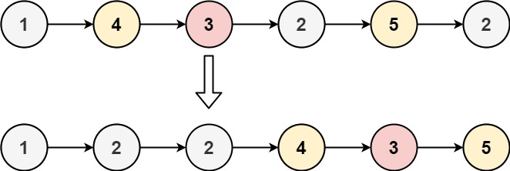
Input: head = [1,4,3,2,5,2], x = 3
Output: [1,2,2,4,3,5]
Example 2:
Input: head = [2,1], x = 2
Output: [1,2]
Constraints:
- The number of nodes in the list is in the range [0, 200].
- -100 <= Node.val <= 100
- -200 <= x <= 200
import java.util.*;
public class PartitionList {
public static void main(String[] args) {
LinkedList<Integer> list = new LinkedList<>(Arrays.asList(1,4,3,2,5,2));
int x = 3;
LinkedList<Integer> left = new LinkedList<>();
LinkedList<Integer> right = new LinkedList<>();
for (int val : list) {
if (val < x) left.add(val);
else right.add(val);
}
left.addAll(right);
System.out.println(left); // [1, 2, 2, 4, 3, 5] } }

Problem #206 — Reverse Linked List
✅ Using Collections.reverse()
import java.util.*;

public class ReverseList {
public static void main(String[] args) {
LinkedList<Integer> list = new LinkedList<>(Arrays.asList(1,2,3,4,5));
Collections.reverse(list);
System.out.println(list); // [5, 4, 3, 2, 1]
}
}

🧩 Problem #234 — Palindrome Linked List
✅ Using ArrayList comparison
import java.util.*;

public class PalindromeList {
public static void main(String[] args) {
LinkedList<Integer> list = new LinkedList<>(Arrays.asList(1,2,2,1));
List<Integer> reversed = new ArrayList<>(list);
Collections.reverse(reversed);
System.out.println(list.equals(reversed)); // true
}
}
Problem #92 — Reverse Linked List II (Partial Reverse)
Given the head of a singly linked list and two integers left and right where left <= right, reverse the nodes of the list from position left to position right, and return the reversed list.
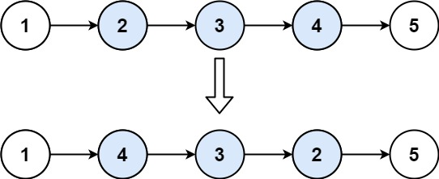
import java.util.*;
public class ReverseBetween {
public static void main(String[] args) {
LinkedList<Integer> list = new LinkedList<>(Arrays.asList(1,2,3,4,5));
int left = 2, right = 4;

List<Integer> sub = new ArrayList<>(list.subList(left-1, right));
Collections.reverse(sub);

for (int i = 0; i < sub.size(); i++) {
list.set(left - 1 + i, sub.get(i));
}

System.out.println(list); // [1, 4, 3, 2, 5]
}
}

Problem #160 — Intersection of Two Linked Lists
Given the heads of two singly linked-lists headA and headB, return the node at which the two lists intersect. If the two linked lists have no intersection at all, return null.
For example, the following two linked lists begin to intersect at node c1:
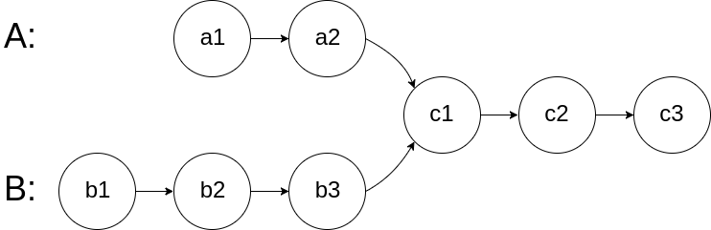

import java.util.*;

public class IntersectionList {
public static void main(String[] args) {
LinkedList<Integer> listA = new LinkedList<>(Arrays.asList(4,1,8,4,5));
LinkedList<Integer> listB = new LinkedList<>(Arrays.asList(5,6,1,8,4,5));

listA.retainAll(listB);
System.out.println(listA); // [1, 8, 4, 5] — intersection elements
}
}

23. Merge k Sorted Lists
You are given an array of k linked-lists lists, each linked-list is sorted in ascending order.
Merge all the linked-lists into one sorted linked-list and return it.
Example 1:
Input: lists = [[1,4,5],[1,3,4],[2,6]]
Output: [1,1,2,3,4,4,5,6]
Explanation: The linked-lists are:
[
1->4->5,
1->3->4,
2->6
]
merging them into one sorted linked list:
1->1->2->3->4->4->5->6
Example 2:
Input: lists = []
Output: []
Example 3:
Input: lists = [[]]
Output: []

Constraints:
- k == lists.length
- 0 <= k <= 10⁴
- 0 <= lists[i].length <= 500
- -10⁴ <= lists[i][j] <= 10⁴
- lists[i] is sorted in ascending order.
- The sum of lists[i].length will not exceed 10⁴.

Solution:
import java.util.*;
public class MergeKSortedListsJCF {
public static void main(String[] args) {
// Step 1: Represent k sorted linked lists as individual LinkedLists
List<LinkedList<Integer>> lists = new ArrayList<>();
lists.add(new LinkedList<>(Arrays.asList(1, 4, 5)));
lists.add(new LinkedList<>(Arrays.asList(1, 3, 4)));
lists.add(new LinkedList<>(Arrays.asList(2, 6)));

// Step 2: Use a PriorityQueue (Min-Heap) to store all numbers
PriorityQueue<Integer> pq = new PriorityQueue<>();

// Step 3: Add all elements from all lists to PriorityQueue
for (LinkedList<Integer> list : lists) {
pq.addAll(list);
}

// Step 4: Extract elements from heap in sorted order
LinkedList<Integer> mergedList = new LinkedList<>();
while (!pq.isEmpty()) {
mergedList.add(pq.poll()); // poll() removes and returns smallest element
}

// Step 5: Output
System.out.println("Merged Sorted List: " + mergedList);
}
}
24. Swap Nodes in Pairs
Given a linked list, swap every two adjacent nodes and return its head. You must solve the problem without modifying the values in the list's nodes (i.e., only nodes themselves may be changed.)

Example 1:
Input: head = [1,2,3,4]
Output: [2,1,4,3]
Explanation:
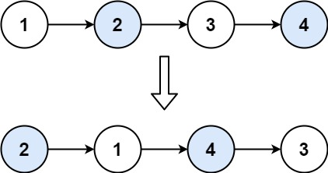
Example 2:
Input: head = []
Output: []
Example 3:
Input: head = [1]
Output: [1]
Example 4:
Input: head = [1,2,3]
Output: [2,1,3]

Constraints:
- The number of nodes in the list is in the range [0, 100].
- 0 <= Node.val <= 100

import java.util.*;

public class SwapNodesInPairsCustomLogic {
public static void main(String[] args) {
LinkedList<Integer> list = new LinkedList<>(Arrays.asList(1, 2, 3, 4, 5));

// Step 1: Swap adjacent elements using custom logic
for (int i = 0; i < list.size() - 1; i += 2) {
// Step 2: get current and next
int first = list.get(i);
int second = list.get(i + 1);

// Step 3: replace them in swapped order
list.set(i, second);
list.set(i + 1, first);
}
// Step 4: Print final result
System.out.println("Swapped List: " + list);
}
}

Solution 2:
import java.util.*;
public class SwapNodesInPairsJCF {
public static void main(String[] args) {
LinkedList<Integer> list = new LinkedList<>(Arrays.asList(1, 2, 3, 4));
// Step 1: Traverse in steps of 2
for (int i = 0; i < list.size() - 1; i += 2) {
// Step 2: Swap i and i+1
Collections.swap(list, i, i + 1);
}
// Step 3: Output
System.out.println("Swapped List: " + list);
}
}

